Client Name:
Roland
Client Address:
1010 Suncrest Street, Bryan, 77803
Phone Number:
979-599-0073

Distance from the Church:
2.4 miles - 8 minutes

Description of the work:
Demo existing porch
Rebuild porch

Other Notes:
There is a metal roof that will determine the exact size of the deck
Look into adding gutter that is on site to roof
Little shade

Site Pictures
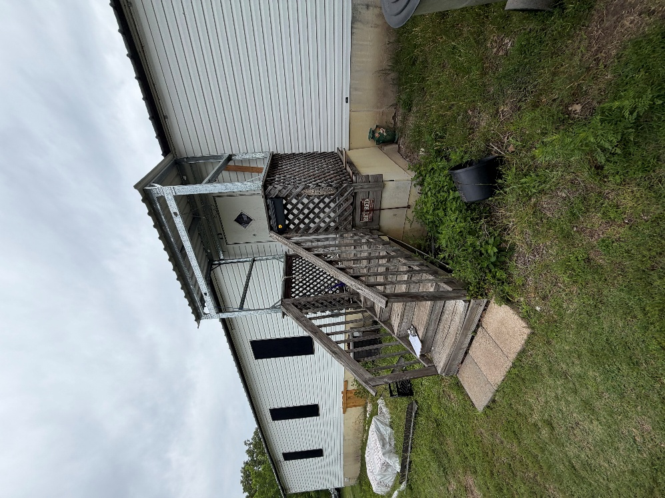
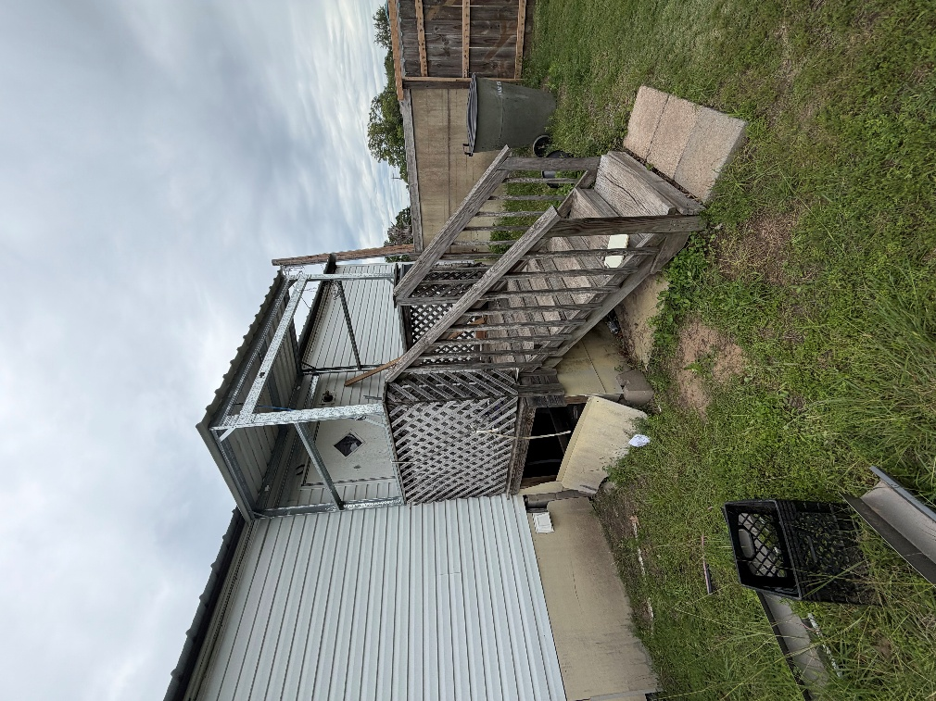
Rendered Project
“Build to site not to plan”

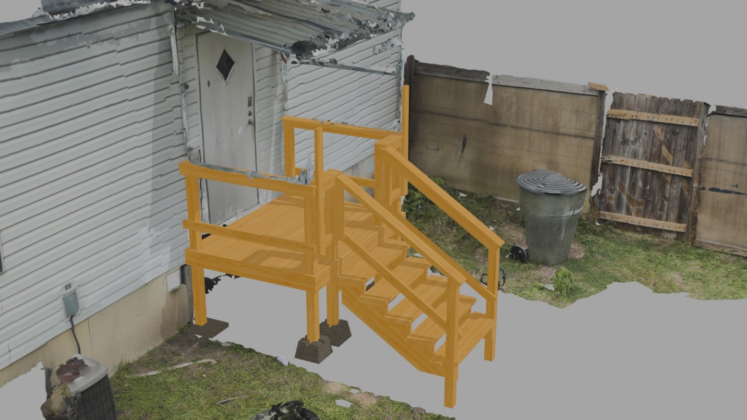
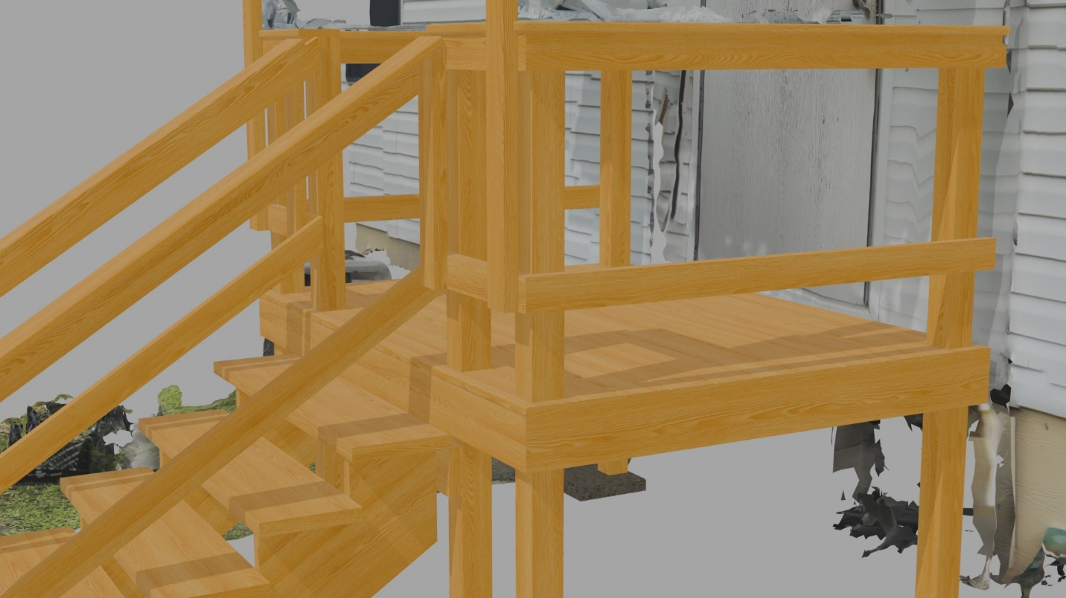
Building Notes
- Frame
  - Width and length should match the roof
  - Add extra 4ft 2x4 to better support the roof in the front
- Handrails and posts
  - Check with clients with how they would like the stairs, design shown is in the middle
    - If client wants the stairs to either side of the deck you can save a post
- Decking
  - Might want to start with the complex first cut with the 4 posts
    - Support any part of the deck with cleats if needed
- Stairs
  - Do NOT trust the design
  - Remeasure and recalculate on site

